**Assignment 3**

--Assignment 3

CREATE TABLE Department(

dept_id int NOT NULL Primary Key,

dept_name varchar(50) NOT NULL

);

CREATE TABLE Employee(

emp_id int NOT NULL Primary Key,

dept_id int NOT NULL,

mngr_id int NOT NULL,

emp_name varchar(50) NOT NULL,

salary float NOT NULL,

Foreign Key(dept_id) References Department(dept_id)

);

INSERT INTO Department

VALUES (1001,'finance'),

(2001,'audit'),

(3001,'marketin'),

(4001,'production');

INSERT INTO Employee

VALUES (1,1001,101,'john',35000),

(2,2001,102,'mike',35433),

(3,3001,103,'rohan',46000),

(4,2001,101,'jeet',25400),

(5,4001,101,'meet',61000),

(6,1001,102,'kivi',33530),

(7,2001,101,'neha',32320),

(8,4001,103,'mena',45000),

(9,3001,103,'tina',43220),

(10,3001,102,'sohan',54320),

(11,2001,102,'mira',23444),

(12,1001,104,'mohan',54322);

1. --1st write a SQL query to find Employees who have the biggest salary in their Department

SELECT e.emp_name,

e.dept_id,e.salary

FROM Employee e

WHERE e.salary IN

(SELECT max(salary)

FROM Employee

GROUP BY dept_id HAVING dept_id=e.dept_id);

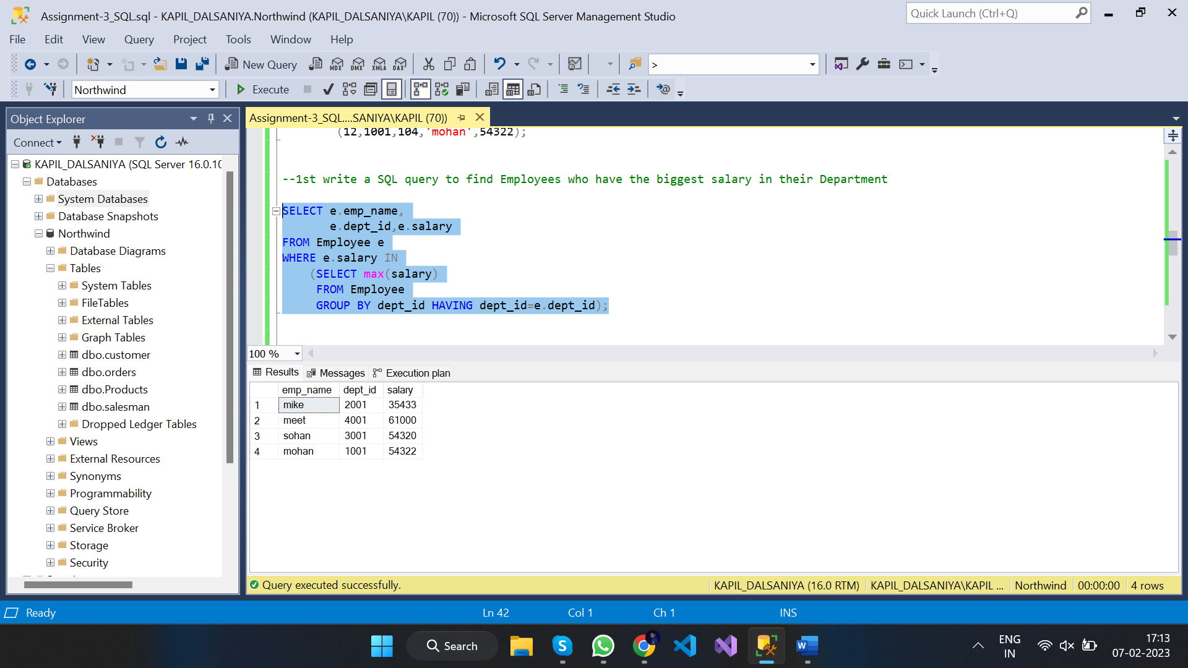

1. --2nd write a SQL query to find Departments that have less than 3 people in it

SELECT d.dept_name,COUNT(e.emp_id)

FROM Employee e

RIGHT OUTER JOIN Department d

ON d.dept_id = e.dept_id

GROUP BY d.dept_name

HAVING COUNT(e.emp_id) < 3;

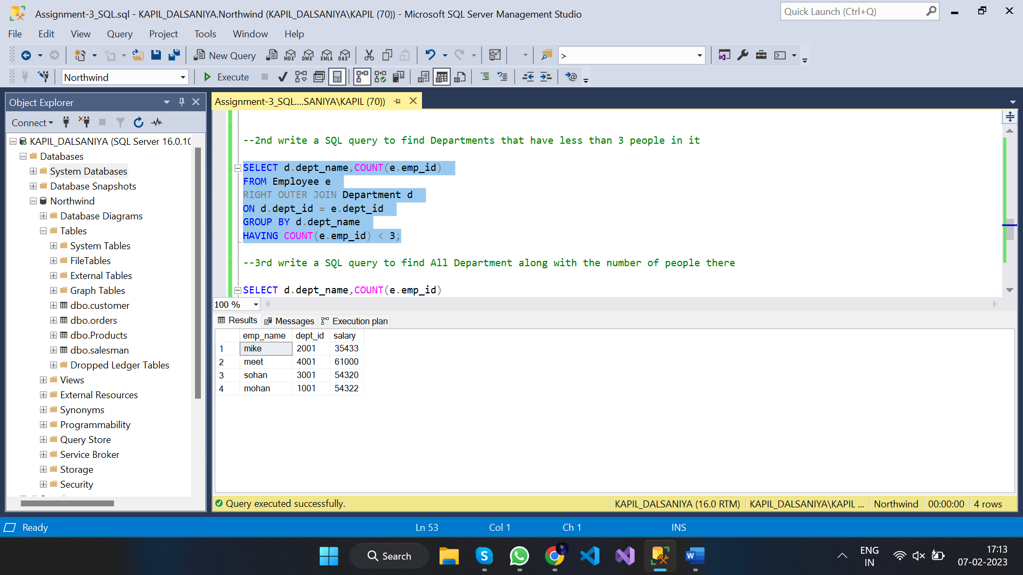

1. --3rd write a SQL query to find All Department along with the number of people there

SELECT d.dept_name,COUNT(e.emp_id)

FROM Employee e

RIGHT OUTER JOIN Department d

ON d.dept_id = e.dept_id

GROUP BY d.dept_name;

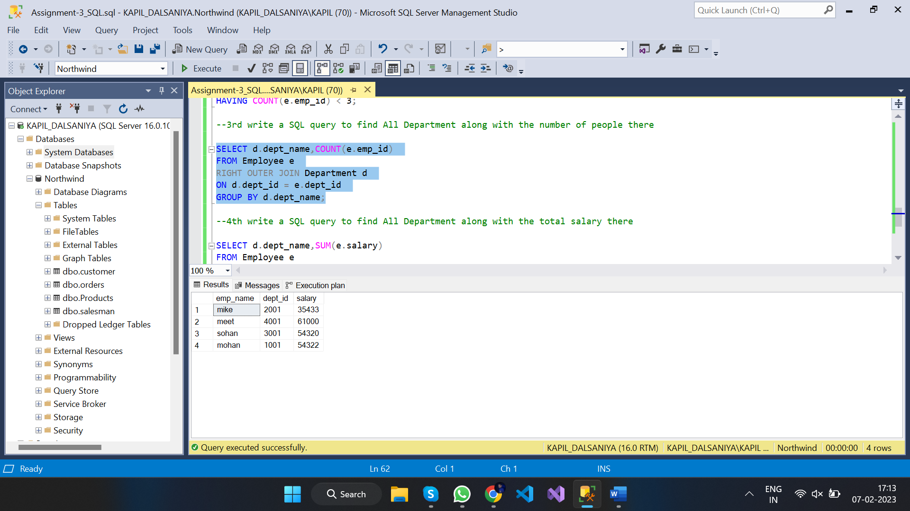

1. --4th write a SQL query to find All Department along with the total salary there

SELECT d.dept_name,SUM(e.salary)

FROM Employee e

RIGHT OUTER JOIN Department d

ON d.dept_id = e.dept_id

GROUP BY d.dept_name;

